Deep-Learning Crater Detection and Segmentation for Autonomous Navigation

Pratheek Ramakrishna, Mehiret Aga

ABSTRACT
In this paper we present a preliminary dataset for use in training lunar crater detection and segmentation models. Our dataset includes 1321 synthetic images with crater segmentation masks and associated bounding boxes for lunar craters. Accurate, autonomous crater detection can be applied to both research as well as potential autonomous navigation of spacecraft. Advanced deep learning models have shown promise in crater identification but they require comprehensive training data. Many existing datasets for crater detection training either lack a multitude of poses and/or lack various lighting conditions, leading incorrect assumptions about craters and suboptimal performance. To rectify this, our dataset includes images taken from varied poses and lighting conditions, providing a more diverse dataset. In this paper we discuss existing datasets, the process of creating our dataset, evaluate the performance of our dataset, and test our model on real images of lunar craters. We then discuss potential improvements that can be made to our model.

INTRODUCTION
As the field of space exploration continues to advance, the exploration of the moon will only tend to increase. Thus, accurate crater detection is vital for safe space flights as with understanding the location of the crater as well as the size, we would be able to safely land a higher number of spacecrafts on planets and moons. Through 2030, more than 100 mission to the moon have been planned by both government agencies and private companies [1]. Given this increased in interest in the moon, it is important to investigate the possibility of autonomous navigation around the moon. One major aspect of the moon is its craters which would need to be identified so that the autonomous navigation algorithms can make informed decisions to preserve its mission and the safety of the spacecraft.
Optical navigation algorithms have been proposed and implemented with the probe Deep Space 1, launched in 1998, being the first to use images of asteroids against a star backdrop to autonomously determine its relative location [2] . More related to the Moon, Silvestrini et al. as well as Downes et al, have proposed an optical navigation algorithm using convolutional neural networks ([3], [4]). Our paper, therefore, aims to improve crater detection by improving training datasets so that such optical navigation methods can be implemented on space exploration missions.
The majority of object detection datasets are oriented towards terrestrial applications and as there is more interest and investment in space, the number of object detection datasets relating to extraterrestrial applications must increase. Many crater detection models perform well on images but fail on images taken from oblique angles. This leads to a gap in crater detection algorithms because the vast majority of their data is nadir and as a result crater detection models have a harder time detecting craters presented from oblique angles. The process that will be detailed later in this paper will mention how we were able to incorporate oblique images in our dataset.

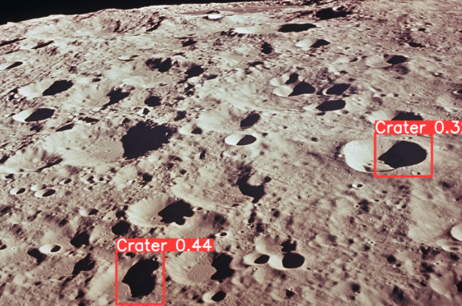Figure 1. Example of an image whose oblique angle makes it difficult for existing object detection models trained on existing crater datasets to detect. Two craters are detected with low certainty and even then, the algorithm seems to detect the crater’s shadow rather than the crater itself.

RELATED WORKS
Several lunar crater detection sets have been created simply for the sake of crater detection and for potential use in space exploration missions. Sinha et al in 2023 [5] created a lunar crater detection dataset from lunar images taken by the Chandrayaan-2 satellite which solely consisted of real images. These images were taken by Terrain Mapping Camera-2 (TMC-2) onboard the Chandrayaan-II satellite. These images were then manually annotated and can be found on Roboflow. The dataset itself consists of a total of 3556 training images. However, a shortcoming of the dataset is that virtually all the images are nadir. Therefore, the dataset is not comprehensive enough and potential models that are trained using the dataset would likely perform sub optimally while detecting craters at oblique angles.
Another relevant dataset is from Palafox et al [6]. They created a dataset of more than 11 000 annotations of craters and crater-free areas on Mars. Instead of labeling all craters in every training image, only 200 annotations were extracted per image in the dataset. This was likely done because all annotations were done manually, leading to a time intensive and laborious process. This is potentially problematic because it may cause models to make incorrect assumptions given insufficient data and it is also possible that some craters were misidentified due to human error.

CREATING THE DATASET

As mentioned in the introduction this dataset only used synthetic data which in future work would be complemented by real data. To create the synthetic dataset, we chose a digital elevation map (DEM) taken by Kayuga, JAXA’s second lunar lander as the DEM was readily available for use.
Along with the DEM we used found Moon Crater Database Robbins (mentioned previously) which contains approximately 1.3 million lunar impact craters and is virtually complete for all craters larger than about 1–2 km in diameter [7]. In order to generate the dataset, a fully autonomous process was used.
First the craters within the DEM had to be identified to demonstrate proof of concept that using Moon Crater Database v1 Robbins data, craters on the DEM could be detected. This was done using a MATLAB program that traversed Moon Crater Database Robbins and determined whether the coordinates of the crater were located within the DEM. If this was the case, the coordinates of the center of the crater as well as its radius in meters were used to plot the crater on the DEM. that was located inside the DEM. Our result was an annotated DEM with green circles demarcating the various craters larger than 1–2 km on the DEM.
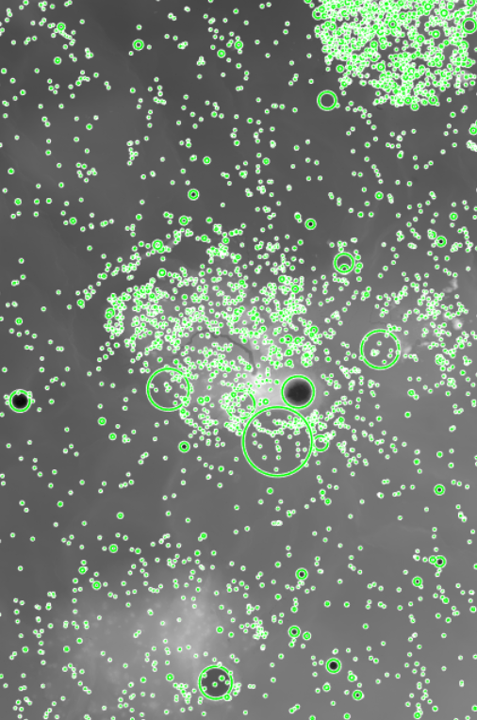
Figure 2. DEM annotated with all the craters in Moon Crater Database v1 Robbins that were located within the frame of the DEM

Given the successful correlation of crater coordinates and radii on Moon Crater Database v1 Robbins to the DEM, it was proven that both could be used to generate a lunar crater training dataset.
The next task was to actually generate the new training data set of lunar craters. That was done using a MATLAB script that took in the DEM and Moon Crater Database v1 Robbins as input and allowed for the adjustment of the yaw, pitch and roll of the camera. The script then rendered images of the moon and provided the coordinates of the crater on the image so that this data can then be used by the YoloV8 algorithm to identify the craters within each image.
To allow for a more comprehensive dataset, we varied the azimuth between 0 and 360 degrees, the elevation between -30 and 30 degrees and rho between -30 and 30 degrees of the camera taking the image.

Demonstrating the flow:
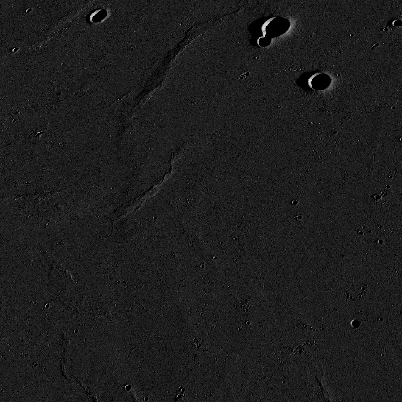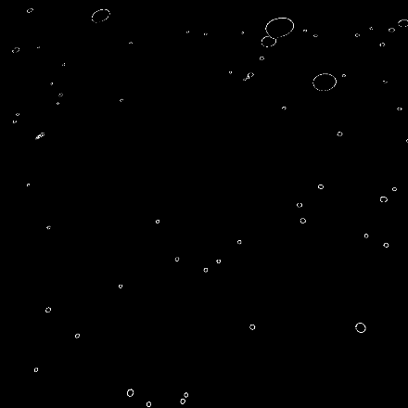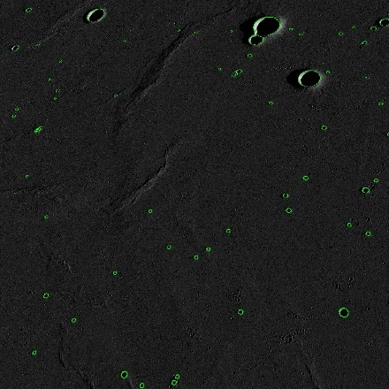

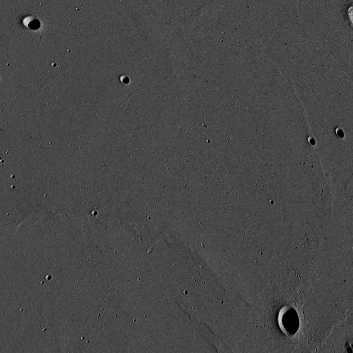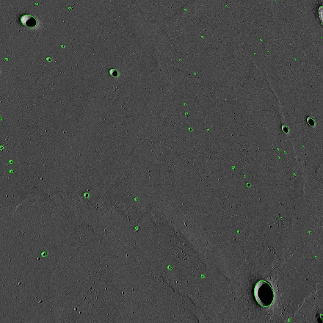

Figure 3. Two examples of the flow of the dataset. The raw frames are located on the left with the segmentation masks in the center and the annotated images located on the right.

PERFORMANCE

For this paper, the Yolov8 object detection from Ultralytics was used to detect craters and produce bounding circles.
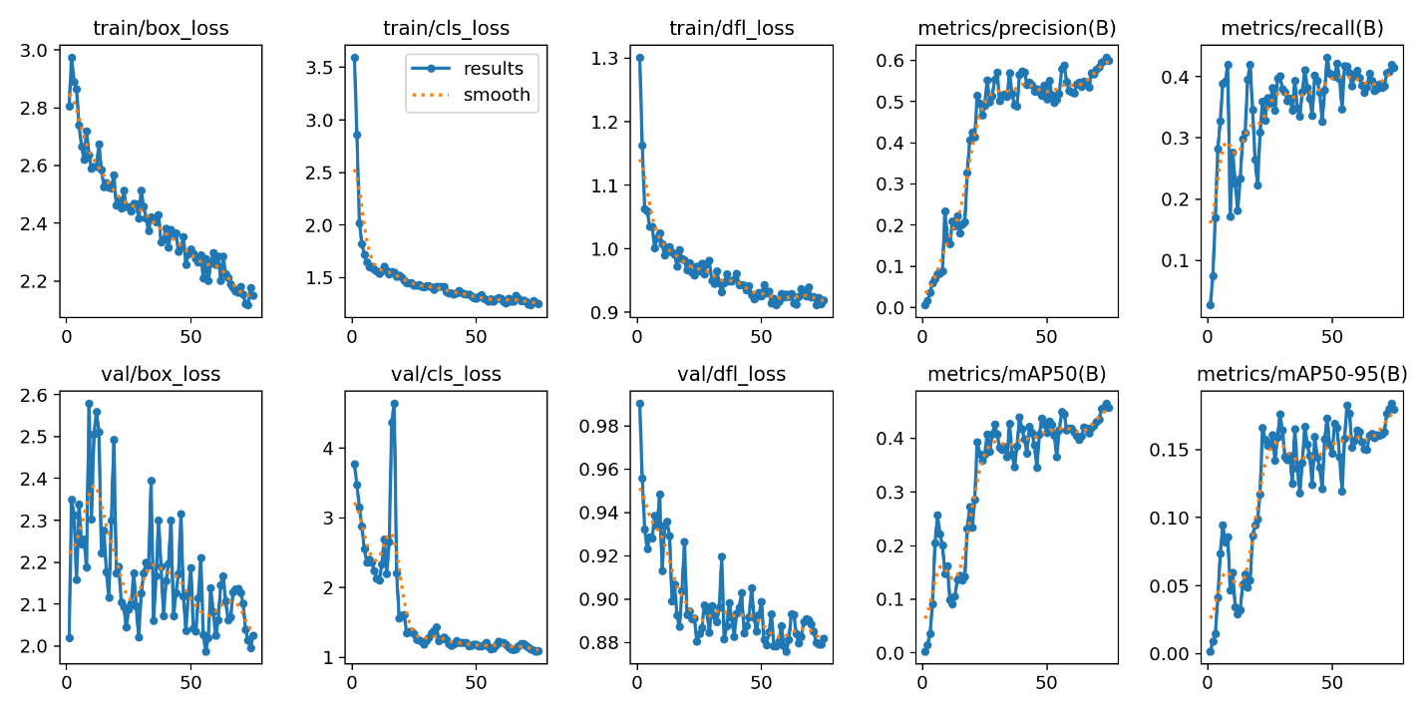
Figure 4. Visualization of the YOLOv8 model training results to 75 epochs.
The Yolov8 model did fairly well on the validation images. In the train/box_loss graph (top right), the pixel difference between the generated bounding box and the actual bounding box reduced from a high of 3 pixels to a low of 2.2 pixels, demonstrating a significant progress.

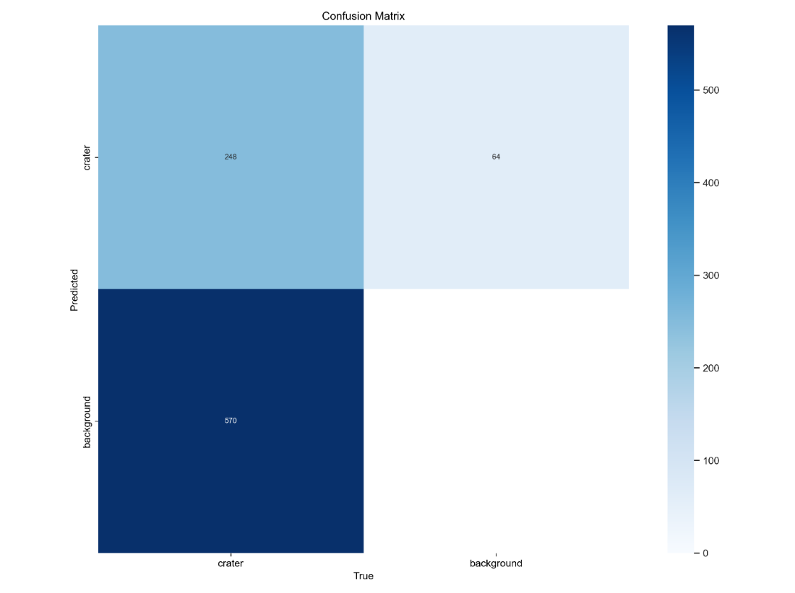

Figure 5. Normalized confusion matrix of the Yolov8 model.

The confusion matrix reveals room for significant improvement in the model as 570 craters across the validation images were considered background by the Yolov8 model. This is likely due to the fact that there were only 108 training images provided to the model and as a result the model is relatively inaccurate. This will be rectified when more images are added to the training and validation datasets.

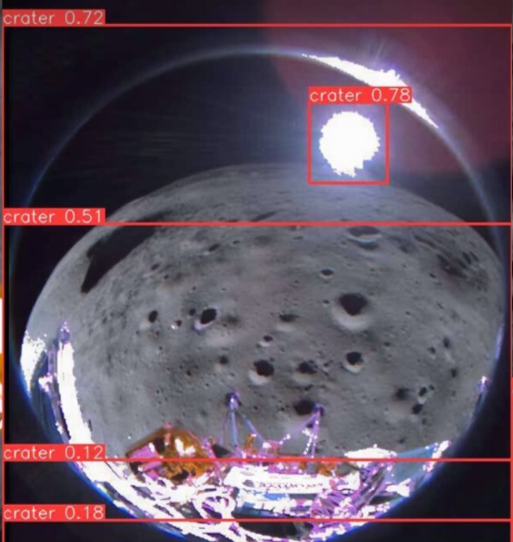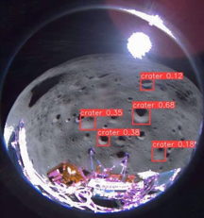

Figure 6. A side-by-side comparison of the Yolov8 model trained on a preexisting dataset (left) and the Yolov8 model trained on our dataset (right).

There is a significant improvement in the right image as compared to the left image in that several craters are detected by the algorithm. Our new model did relatively well even though image that was provided was taken from a fish eye lens and therefore distorted.

CONCLUSION

We propose a lunar crater image dataset for detection and segmentation tasks with significantly more images from oblique angles as compared to existing datasets. Our dataset consists of approximately 121 (108 training and 13 validation) images rendered using data from Lunar Crater Database V1 Robbins. We have also delved into the training performance of the YoloV8 model.
Our dataset will be refined in the future with more images as well as potentially incorporating real images of lunar craters. To incorporate more images we would use other DEMs and repeat the process described in this paper to generate more training and validation data for the model. A further improvement would be using training data of other planets such as Mars to make the algorithm a more comprehensive crater detection model. We would also incorporate higher degrees of oblique imagery so that our dataset is even more comprehensive than it already is. In the future, the Team wants to look at possibility to incorporate into proposed algorithms for lunar autonomous navigation.

ACKNOWLEDGEMENTS

We would like to thank Ike. R. Witte for his valuable mentorship and guidance and thank the JHU APL ASPIRE high school internship program for providing us with the resources and equipment to conduct our research.

CITATIONS

[1] Grush, Loren, et al. “Why World Wants to Get Back to the Moon.” Bloomberg.Com, Bloomberg, 13 May 2024, www.bloomberg.com/features/2024-moon-race-explained/.

[2] Bhaskaran, S., Riedel, J.E., Synnott, S.P., Wang, T.C.: The Deep Space 1 Autonomous Navigation System: A Post-Flight Analysis. In: AIAA/AAS Astrodynamics Specialist Conference. AIAA-2000-3935 (2000). https://doi.org/10. 2514/6.2000-3935

[3] Stefano Silvestrini, Margherita Piccinin, Giovanni Zanotti, Andrea Brandonisio, Ilaria Bloise, Lorenzo Feruglio, Paolo Lunghi, Michèle Lavagna, Mattia Varile, Optical navigation for Lunar landing based on Convolutional Neural Network crater detector, Aerospace Science and Technology, Volume 123, 2022,

107503, ISSN 1270-9638, https://doi.org/10.1016/j.ast.2022.107503.

[4] Downes, L. M., Steiner, T. J., & How, J. P. (2021). Neural network approach to crater detection for Lunar Terrain Relative Navigation. Journal of Aerospace Information Systems, 18(7), 391–403. https://doi.org/10.2514/1.i010884

[5] Sinha, M., Paul, S., Ghosh, M. et al. Automated Lunar Crater Identification with Chandrayaan-2 TMC-2 Images using Deep Convolutional Neural Networks. Sci Rep 14, 8231 (2024). https://doi.org/10.1038/s41598-024-58438-4

[6] Palafox, L. F., Hamilton, C. W., Scheidt, S. P., & Alvarez, A. M. (2017). Automated detection of geological landforms on Mars using Convolutional Neural Networks. Computers & geosciences, 101, 48–56. https://doi.org/10.1016/j.cageo.2016.12.015

[7] Robbins, S. J. (2019). A New Global Database of Lunar Impact Craters &gt;1–2 km: 1. Crater Locations and Sizes, Comparisons With Published Databases, and Global Analysis. In Journal of Geophysical Research: Planets (Vol. 124, Issue 4, pp. 871–892). American Geophysical Union (AGU). https://doi.org/10.1029/2018je005592

